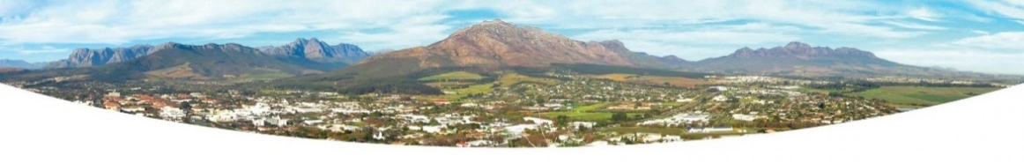


021-808 8343 / 8957 / 8953 Directorate: Infrastructure Services email: engeering.services@stellenbosch.gov.za

NOTICE FOR PUBLIC COMMENT

NOTICE No.: 8/ 2025

CLOSURE OF THE NAGTEGAAL ROAD INTERSECTION WITH DEVON VALLEY ROAD

The Municipality is considering the closure of the Nagtegaal Road Intersection with Devon Valley Road, Onder-Papegaaiberg.

The intersection closure under consideration prohibits direct acces from Devon Valley Road to Nagtegaal Road. Nagtegaal Road remains open and accesible via Tarentaal Road and Hoep-Hoep Road.

Notice is given in terms Council’s Resolution, Item 10.6.3 of the 27th Council Meeting held on the 27 November 2024, to advertise the proposed closure for public comment.

The community and travelling public is therefore invited to provide comment. Comments must clearly state “Closure of the Nagtegaal Road Intersection with Devon Valley Road” and may be forwarded to: Engineering.services@stellenbosch.gov.za or may be submitted to the Municipal Office located at 71 Plein Street, Ecclesia Building, Second Floor.

Any person, unable to read or write or, having any sight disability, will be assisted by an official at the above-mentioned office, should they not be able to provide comments on their own accord.

The Council item and associated report can be downloaded from Stellenbosch Municipality’s website (www.stellenbosch.gov.za).

Comments / inputs must be submitted on or before 28th of February 2025.

Infrastructure Services
21/1/2025

