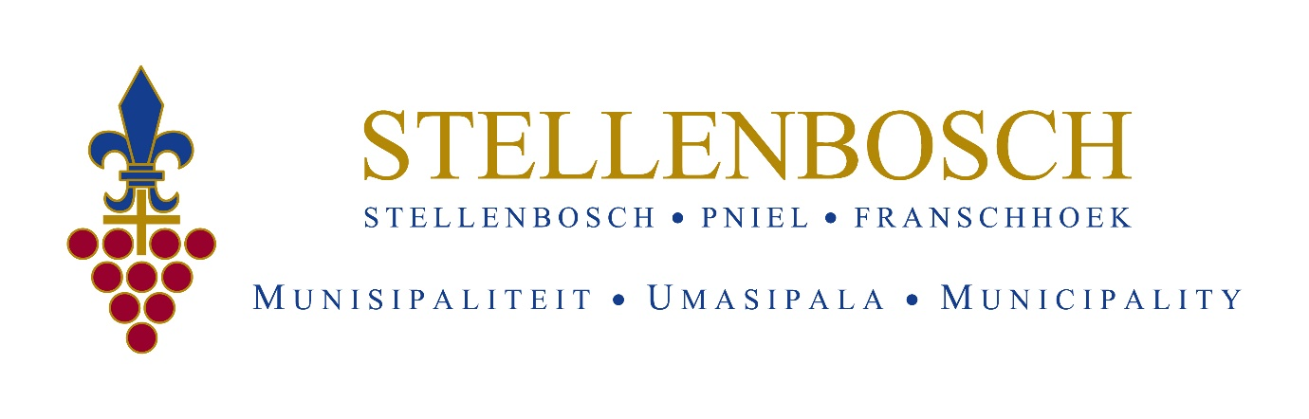
THE STELLENBOSCH MUNICIPAL MAYORAL YOUTH SKILLS DEVELOPMENT PROGRAMME IS OFFERING
ACCREDITED LIFEGUARD TRAINING THROUGH LIFESAVING SOUTH AFRICA
Stellenbosch Municipality through Lifesaving South Africa are calling interested parties to apply for one (1) of ten (10) positions for training as a Pool and Surf Lifeguard in accordance with skills programme LFG/LIFGUARD/4/0088. NQF LEVEL 04.

What are the application criteria?
- Must have a National Senior Certificate or Equivalent with English as one language (certified – not older than 3 months)
- Valid South African ID (certified – not older than 3 months)
- Proof of residency in Stellenbosch Municipal Area
- Unemployed
- Between the ages of 18-35 years
- Must be able to swim 400 m without stopping within 8 minutes. A current swim time must be included in your CV.
- A 2-page Curriculum Vitae
Applicants will be required to submit to a language skills evaluation and attend a swimming fitness and skills assessment on the 26^{th of} September 2023 at the Cloetesville Swimming Pool.

Where do you submit your application?

Applications to be submitted to: headoffice@lifesaving.co.za

Closing date for application:
18 September 2023

